# Criterion C – Development

Word Count: 975

## Advanced Techniques

|  |  |  |  |
| --- | --- | --- | --- |
| **Sr. No.** | **Advanced Technique** | **Purpose** | **Page Number** |
| 1 | Navbar and links | Makes navigation easy for the user as they simply have to click links |  |
| 2 | Password hashing using werkzeug library | To securely store passwords in the database in an encrypted format, and to decrypt them when necessary |  |
| 3 | Session module to access use cookies | To store the email of a user to allow their identity to be known |  |
| 4 | Use of smtplib and ssl modules to send email notifications | To establish a secure connection to the Gmail SMTP server to allow email notifications to be sent |  |
| 5 | JavaScript functions and statements used to fetch and retrieve data, along with async property | Fetches and displays data from database, allowing any necessary filtering. Functions on the data are carried out such that any other functions can be carried out concurrently. |  |
| 6 | pdfkit library along with wkhtmltopdf tool used for pdf generation | These tools are used to generate a formatted pdf report for the current month’s revenue. |  |
| 7 | Use of Jinja to display values from the database | Jinja is used in some places to directly display values such the monthly revenue, the inventory and the product image from the database |  |
| 8 | Facilitating upload of files using werkzeug library modules | Functions from the werkzeug utility library are used to save and secure the images of the products that are uploaded by the user |  |
| 9 | Alembic used to store all database transactions | This is useful in keeping a track of all the changes made to the database, so that these changes can be easily committed and rolled back |  |

## Colour Coding for Annotations

Green = Advanced Technique used

Orange

= Annotation of code

Yellow = Additional Comments

## Navbar and Links

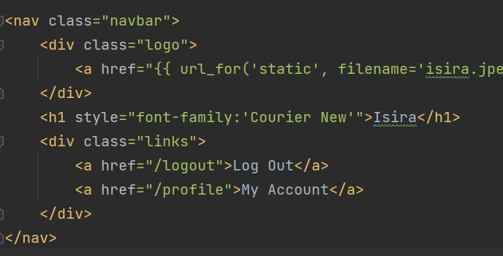

Figure 1: Code containing navbar and links on menu/order page

HTML <a> tags are used to create these links which are displayed on the menu/order page for the user. Each link redirects the user to a particular flask route. Links are formatted using CSS.

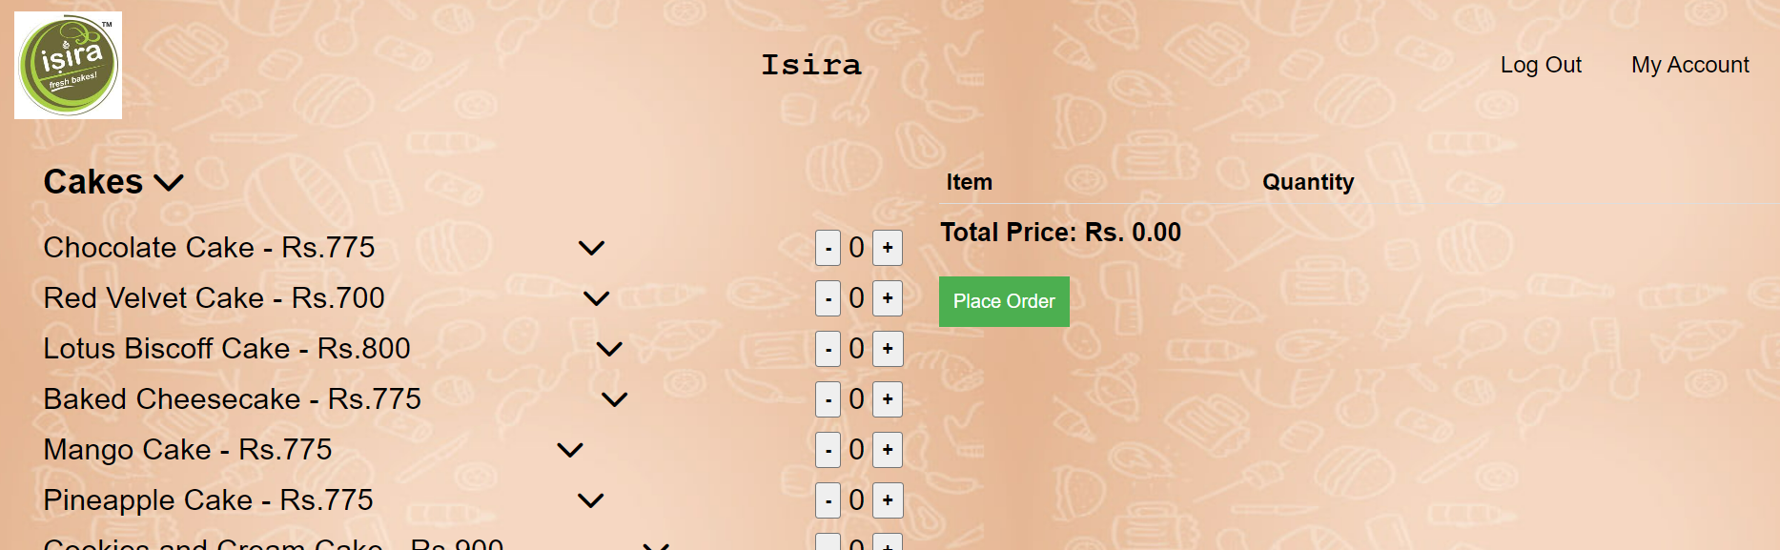

Links after formatting

Figure 2: Order page with links

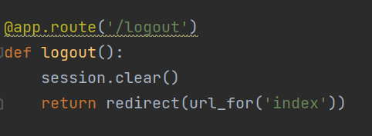

Figure 3: Flask route for 'logout' link

When user clicks ‘Log Out’ link

Similarly, the user is redirected to the profile page through the “/profile” route.

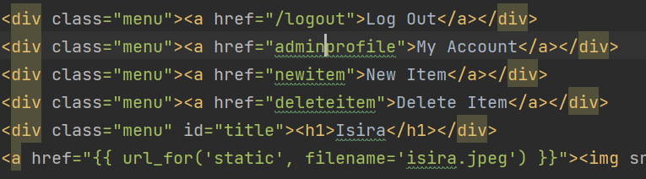

Figure 3: Code for navbar and links in the admin homepage

Links on admin interface.

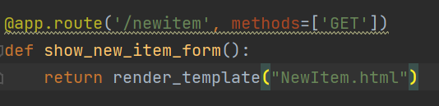

Figure 4: Flask route for the 'newitem' link

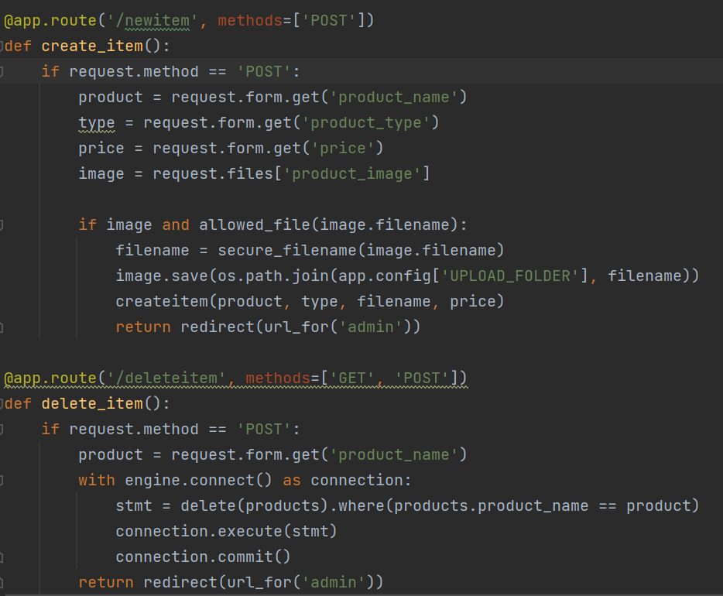

Redirects user to the new item form.

Figure 5: Flask routes for the 'newitem' and 'deleteitem' links

Reroutes the admin to the delete item form.

Links on the admin homepage after CSS formatting

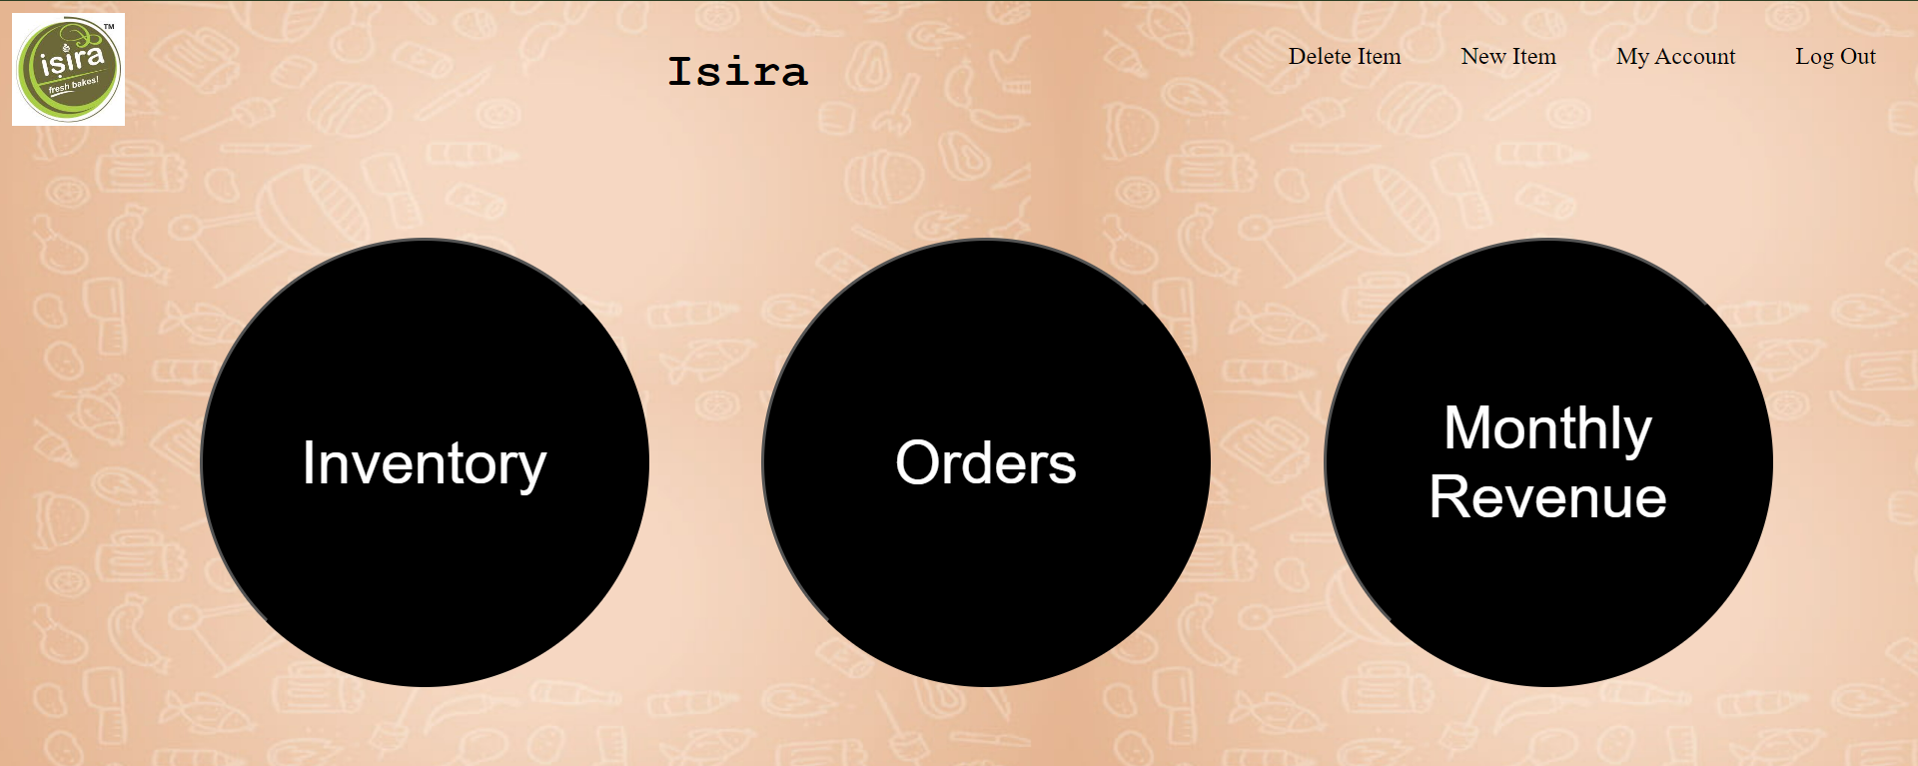

Figure 6: Admin homepage with links

## Password hashing in database

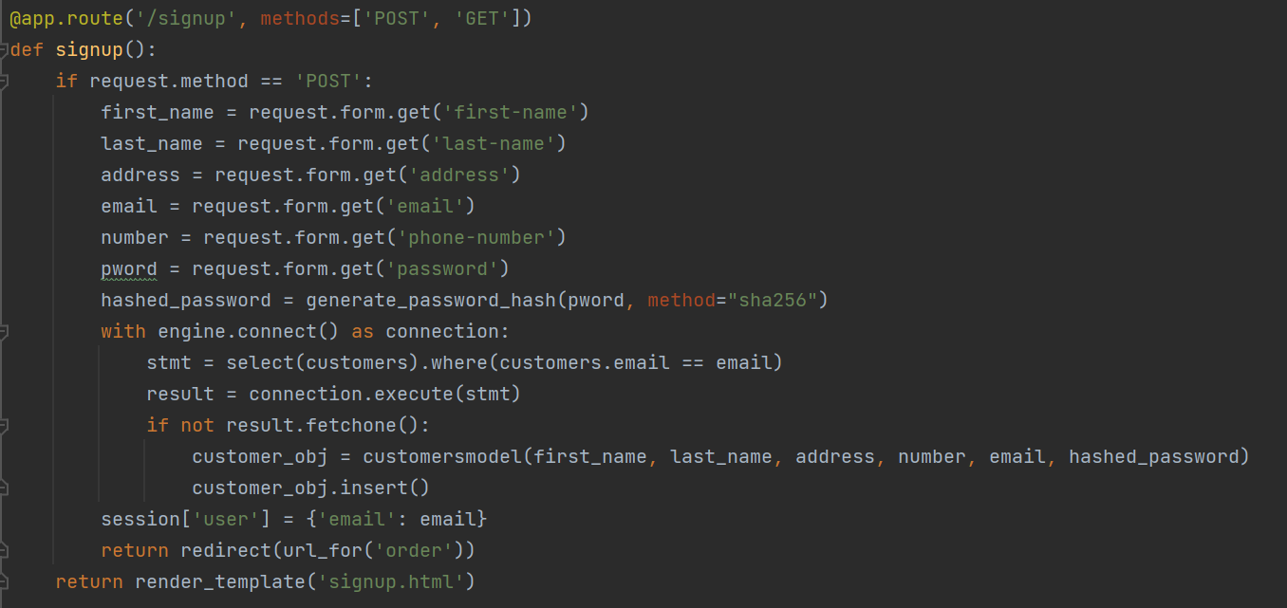

Figure 7: Flask 'signup' route to create a user in the database after signing up

Use of “generate_password_hash” function from the werkzeug.security module. This hashes the password using the “SHA-256” hashing algorithm, which generates a 256-bit output.

The hashed password is added to the customer’s record in the table



Figure 8: Hashed password in database

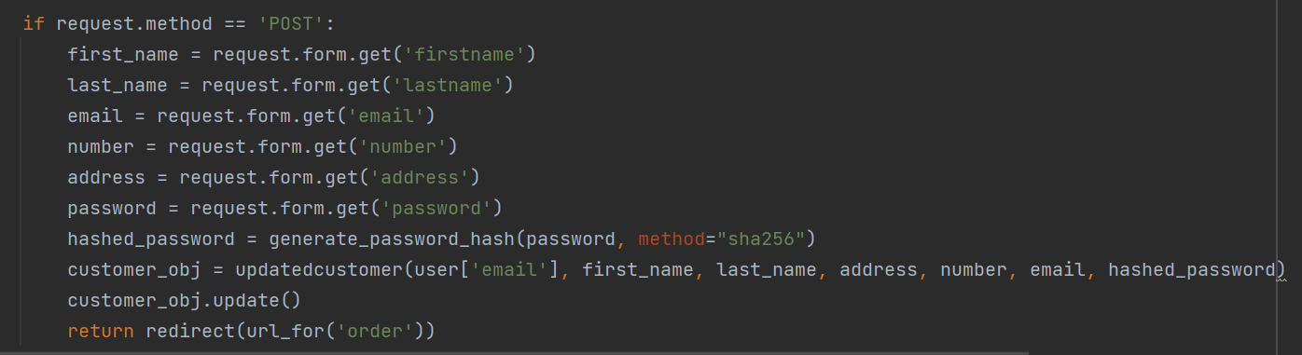

Figure 9: Code for editing user profile

Password is hashed and saved in the database after the profile is edited

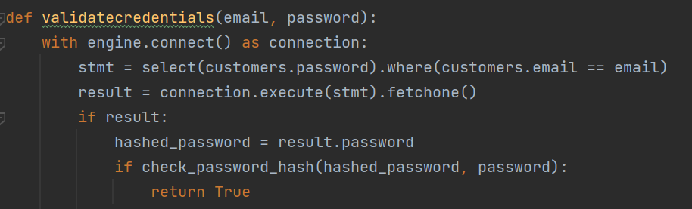

Figure 10: Code for to validate username and password for login

The check_password_hash function, from the werkzeug.security library, is used to compare the password entered by the user with its hashed version in the database. This validates the user password.

## Use of session module for ‘cookies’

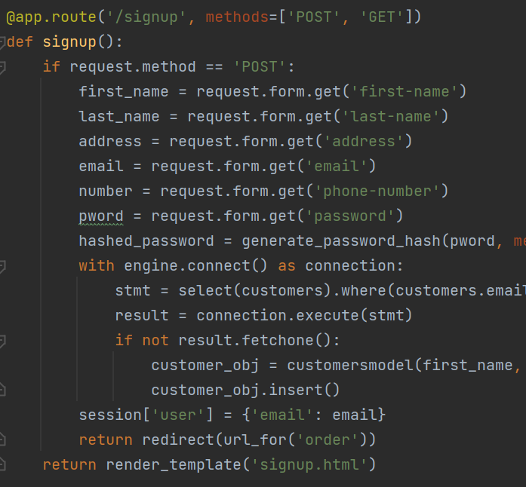

Flask’s ‘session’ module stores the user’s email as cookies so this value can be accessed later in the session to access customer details. This ensures that the customer’s identity can be stored even after they are rerouted from the log-in and sign-up page.

Figure 11: Flask 'signup' route

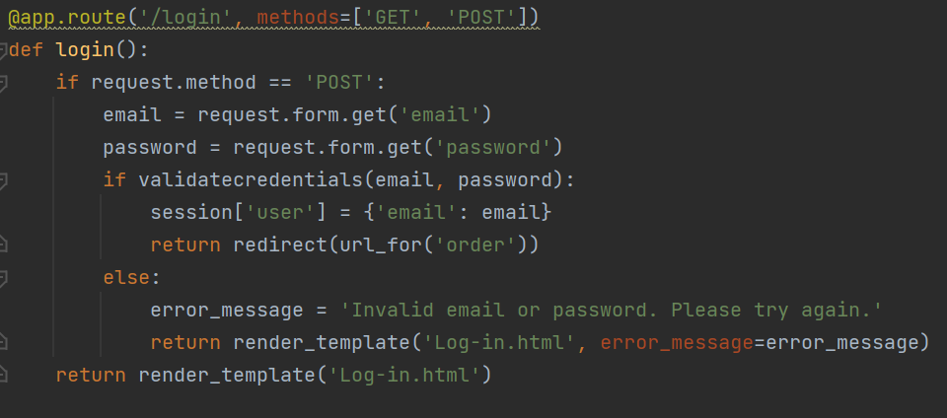

Figure 12: Flask 'login' route

Similar to the ‘signup’ function, if the user’s email and password are found to be valid, the user’s email is stored using cookies.

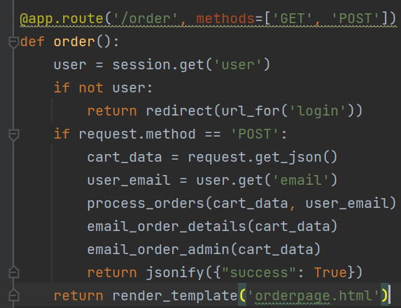

The user email is retrieved from the session cookies and is used to retrieve the customer_id necessary when processing the orders

Checks that a user is logged in before they can access the menu page. The session module is used to see if a user is currently stored using cookies and if they are logged in

Figure 13: Flask 'order' route

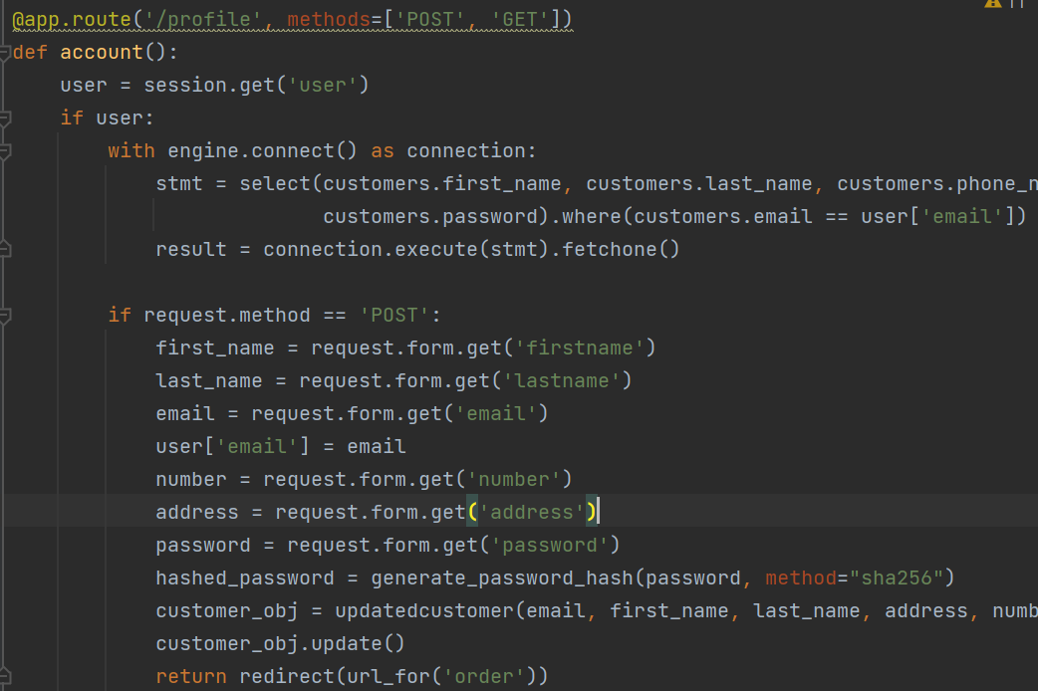

Figure 14: Flask 'profile' route to access profile page

User details are retrieved from the session cookies and used in a query to retrieve the customer’s profile.

Email from edited profile page is now stored in the session cookies.



Figure 15: How the cookie is stored on the network

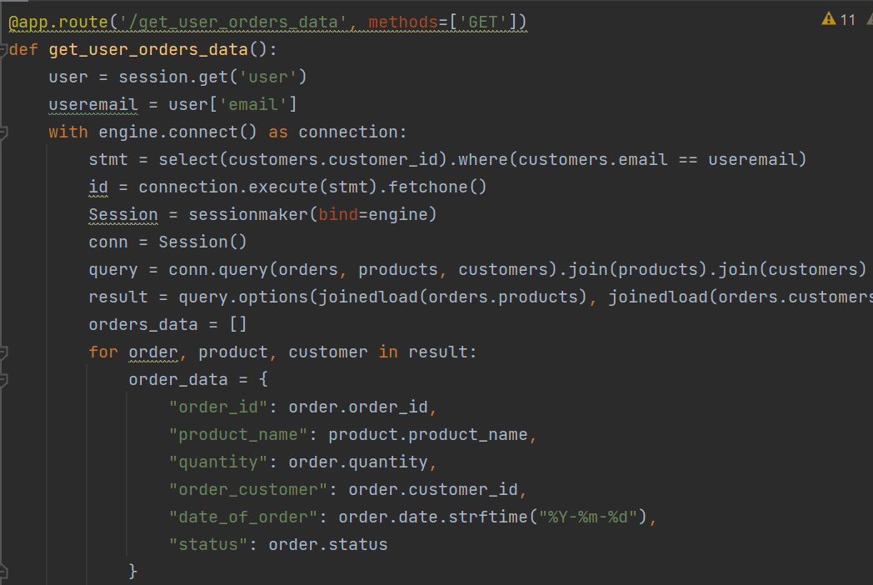

Figure 16: Flask route to retrieve past orders

Email retrieved from cookies and used to retrieve past orders for corresponding customer

## Email Notifications

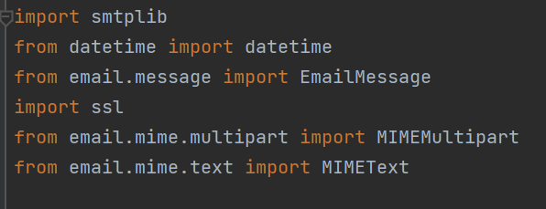

Figure 17: Importing the necessary libraries

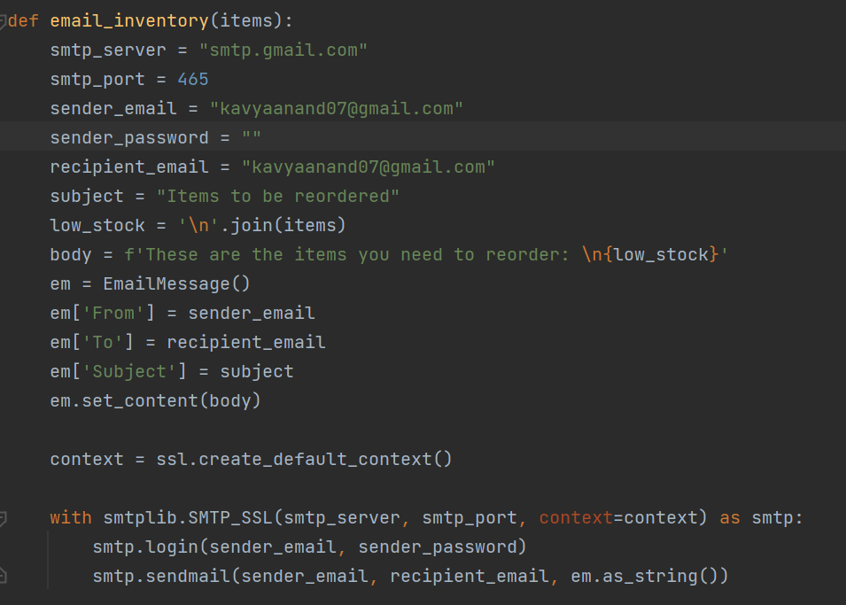

Figure 18: Code for low inventory email

smtplib’s SMTP_SSL function is used to log-in to the sender’s gmail smtp server over an SSL connection, and send the email.

The ‘email’ package in Python is used to define the email’s structure, including the sender, recipient, subject and body.

The ‘ssl’ module is used to create an environment with the necessary protocols for secure communication using SSL

Defining the smtp server and the port. Email sent using gmail, so gmail’s smtp server is used. The port used is 465, which allows secure transmission using SSL or TLS.

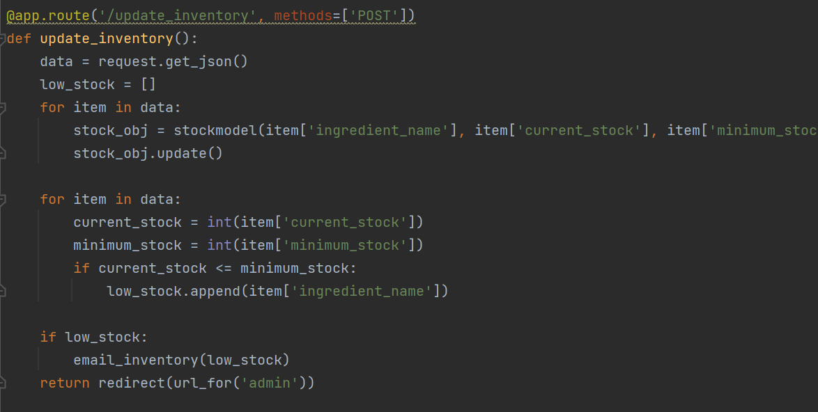

‘email_inventory’ function called if an ingredient’s current stock is lower than the minimum stock

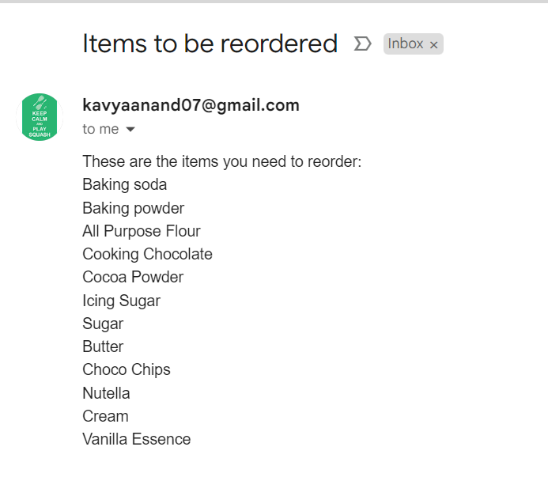

Figure 19: Resulting email that is sent

Similarly, this code has been used to generate multiple other email notifications, including low stock, order confirmation to customer, order notification to admin, dispatched notification and preparation notification.

## Use of JavaScript functions and statements to access flask routes, and to retrieve and filter data

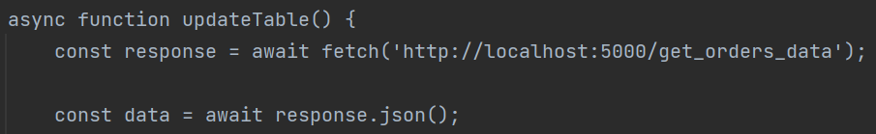

Uses the ‘fetch’ command to get data in .json format from the ‘/get_orders_data’ route

Figure 20: JavaScript on the adminorders.html page to retrieve orders data

‘Async’ property used to define the function, allowing the updateTable function to be executed and the result dynamically displayed, concurrently to other functions that may be occurring

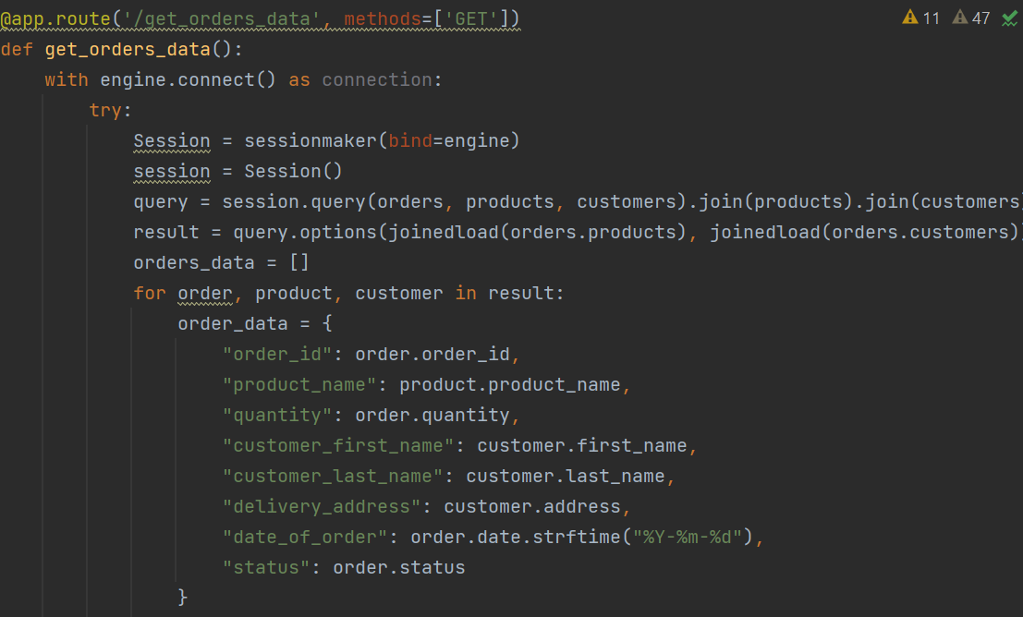

Figure 21: Flask route with query and function to retrieve data

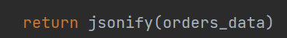

Figure 22: Returns data to page in .json form

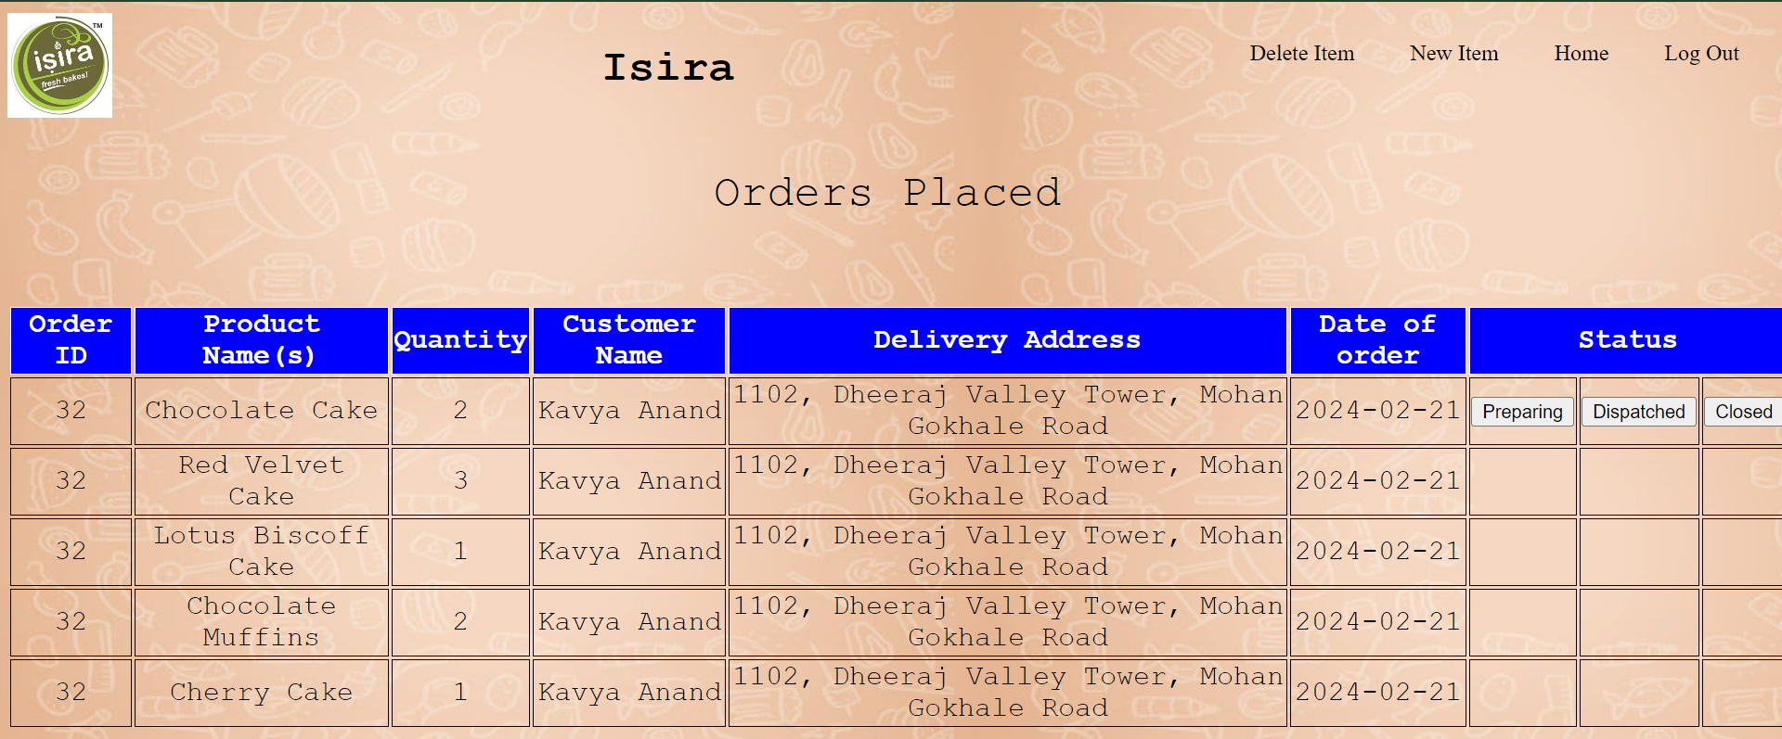

Figure 23: Data fetched and displayed using 'fetch' function and route

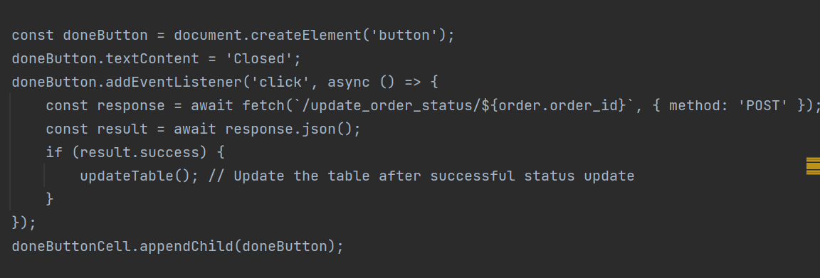

Figure 24: Code for 'Closed' button on pending orders page

Use of ‘await’ and ‘async’ ensure that the functions are asynchronous and the route’s function is executed separately (doesn’t interfere with other functions)

As a result of the asynchronous nature of the updateTable function, while the table’s data is being updated, other functions can be performed. For example, the client can change the status of other orders, or simply scroll on the page, allowing for a more responsive experience.

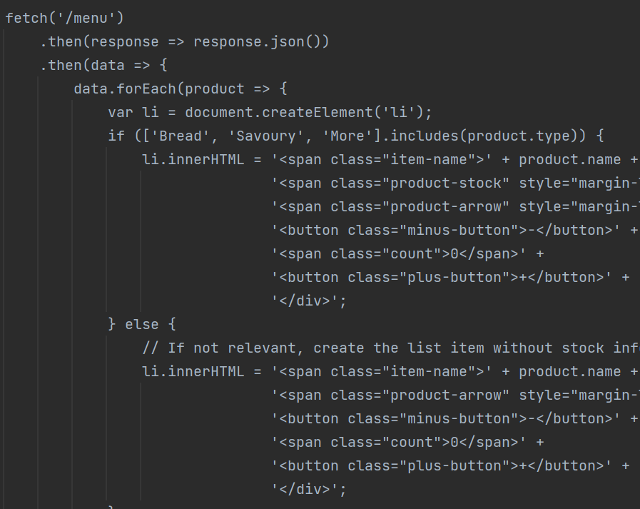

JavaScript if…else statement used to differentiate between readymade (Breads, Savoury and More) products and cakes: only displays stock for readymade products

Use of fetch function to access ‘/menu’ route and retrieve products data to fill the menu

Figure 25: Code for retrieving data from '/menu' route

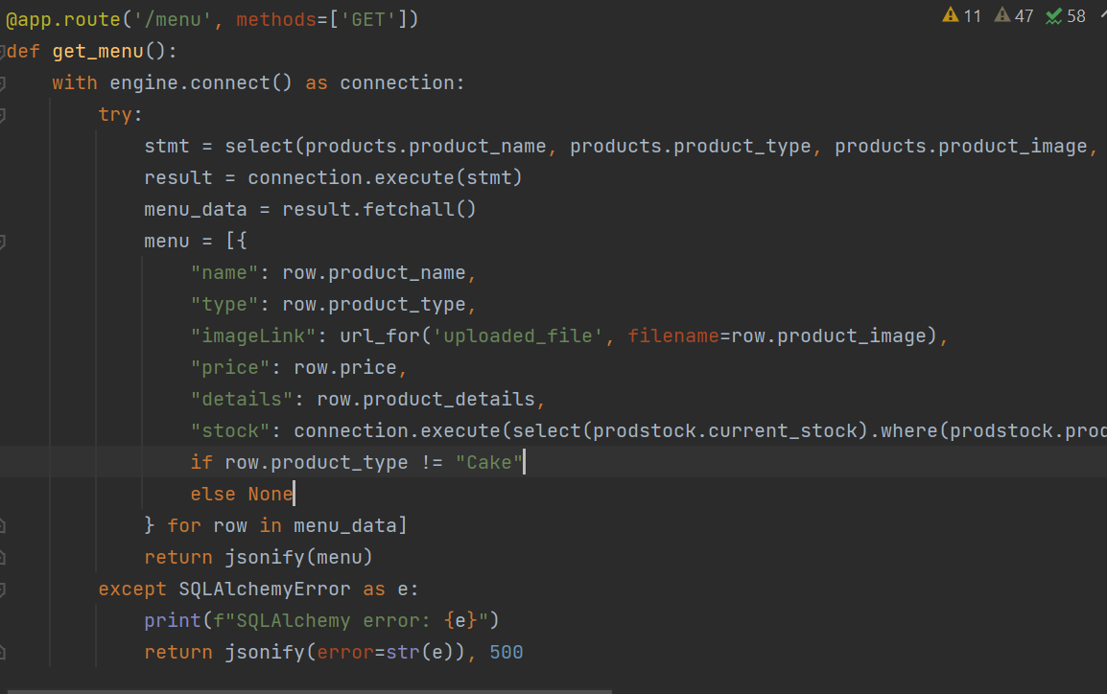

Figure 26: Flask '/menu' route to retrieve products data

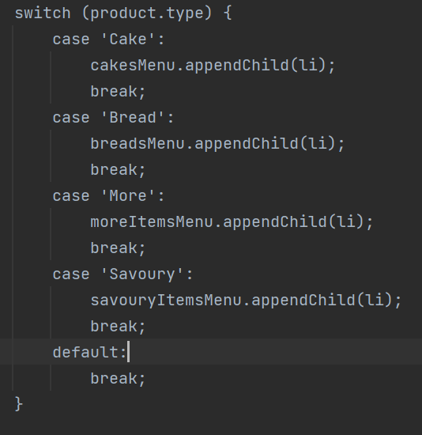

JavaScript ‘switch’ statement is used to filter the types of products to add them to different sections of the menu

Figure 27: Code to filter data into sections of menu

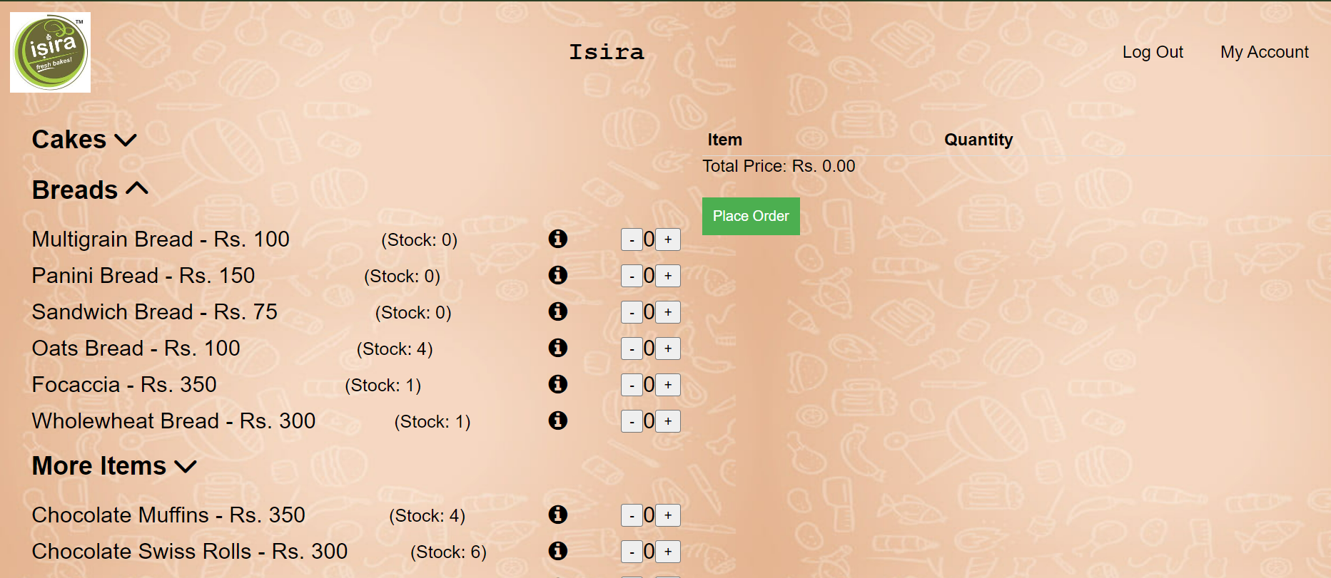

Figure 28: Resulting data (filtered by category into sections)

## PDF Generation using ‘pdfkit’ library and ‘wkhtmltopdf’ tool

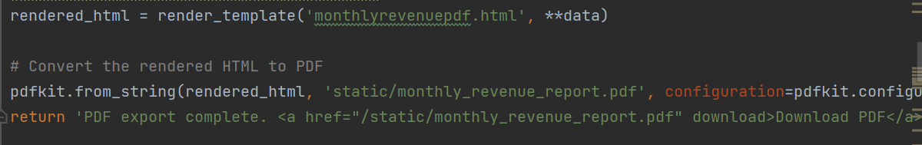

Figure 29: Code to generate pdf



Figure 30: Completing the code in Figure 30

Path to the wkhtmltopdf tool which is used to convert the html into a pdf.

Pdfkit’s ‘from_string’ function converts html page into a pdf file, and stores it in the location mentioned

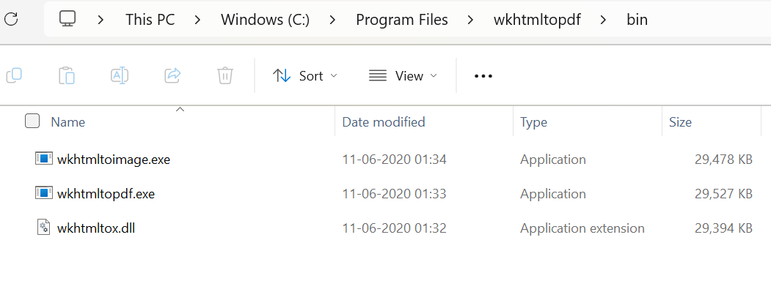

Figure 31: Path to wkhtmltopdf executable file

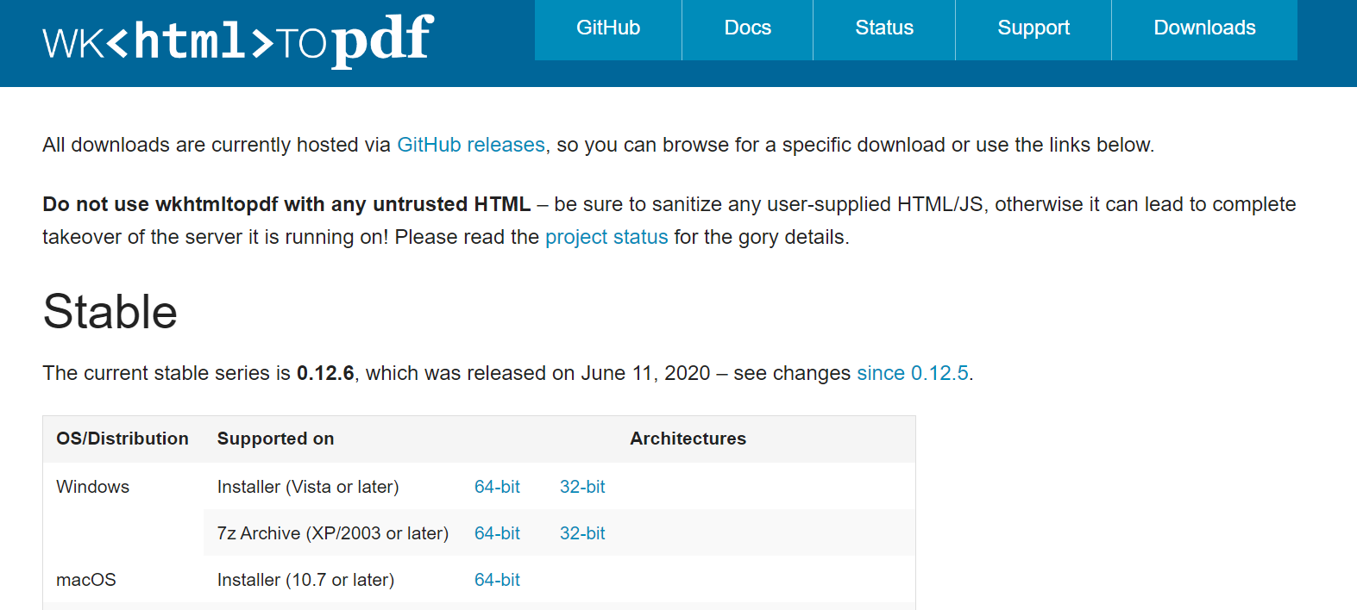

Figure 32: Download page on wkhtmltopdf website

Wkhtmltopdf must be downloaded onto the device

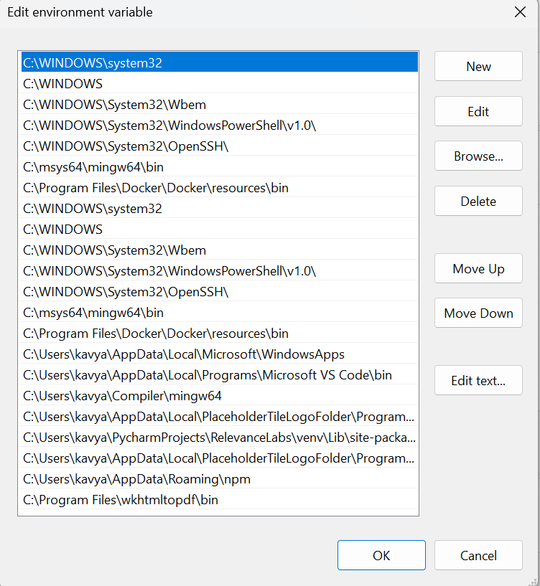

Path to directory containing wkhtmltopdf executable file stored in environment variables

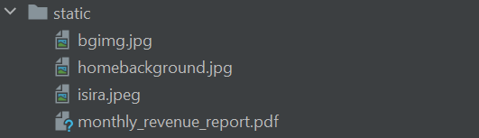

Revenue report added to ‘static’ folder

Figure 33: Static folder after revenue report has been generated

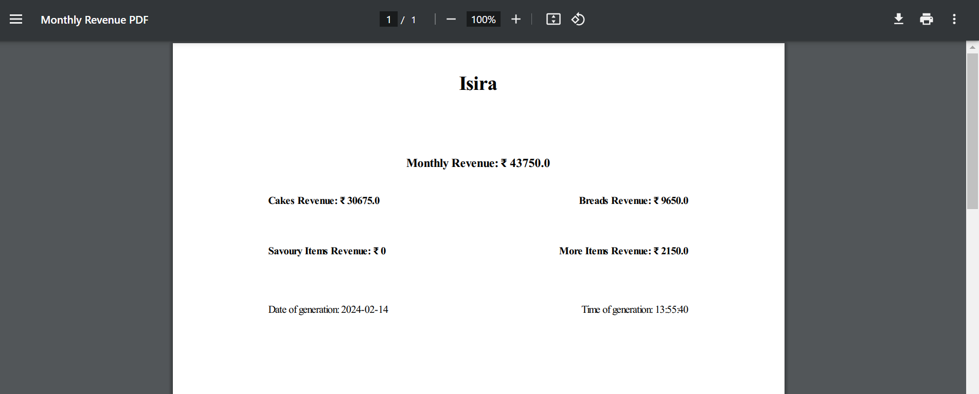

Figure 34: Revenue report PDF

## Use of Jinja to display values from database

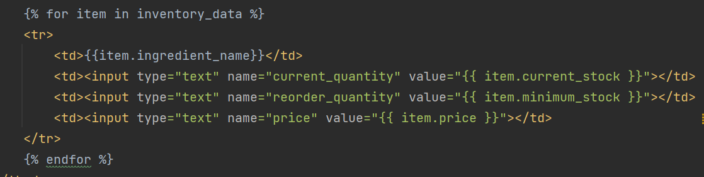

Default values are inserted into input boxes using Jinja

For loop implemented using Jinja to iterate table (rows) for all items

Figure 35: Jinja in inventory html code

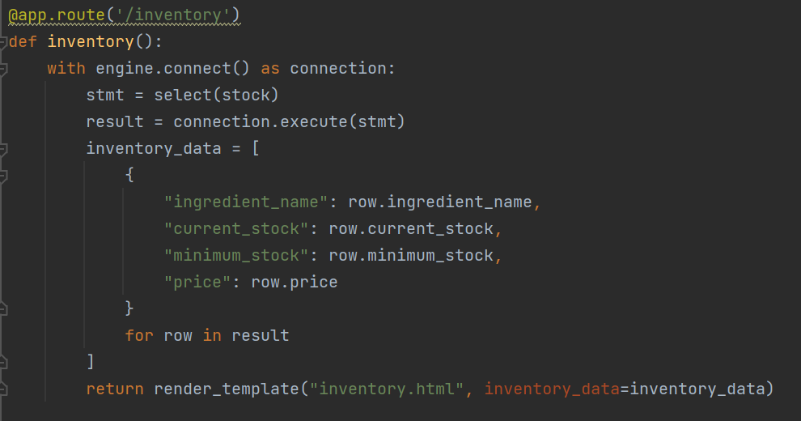

Figure 36: Flask '/inventory' route

Values for “inventory_data” have to be passed to the “render_template” function so that they can be rendered using the Jinja logic

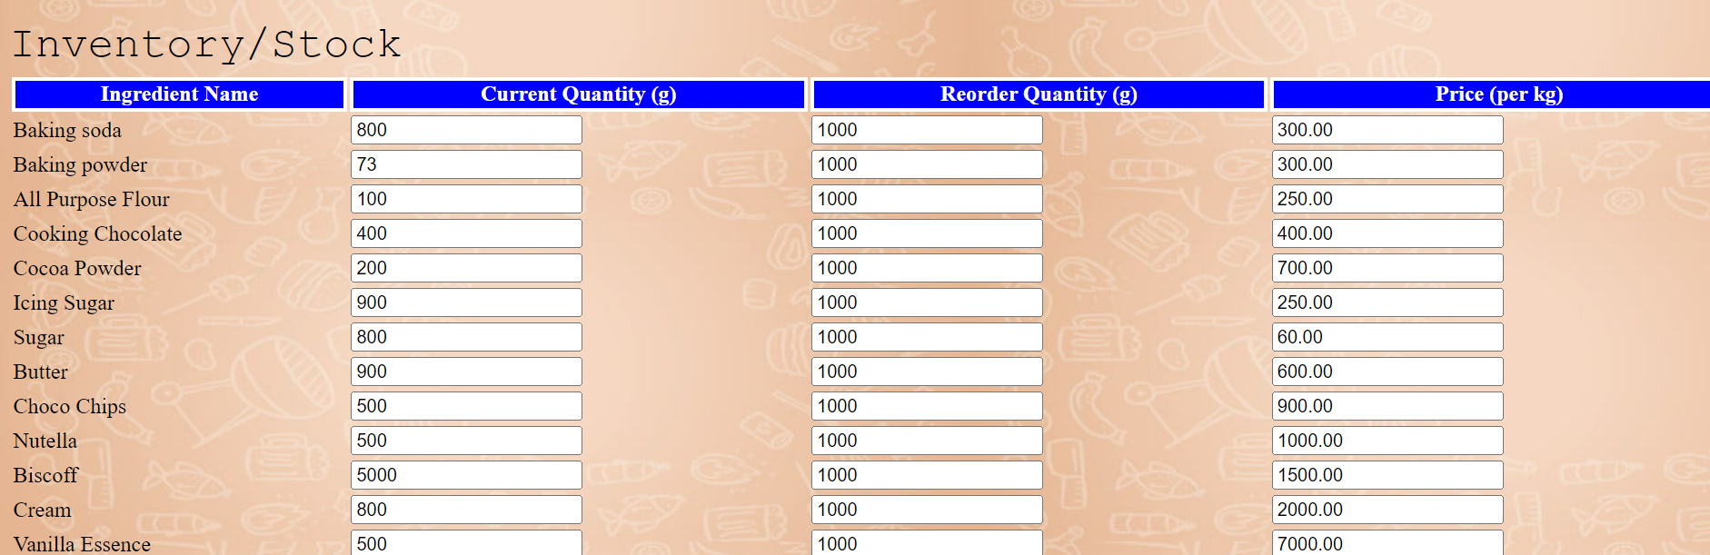

Figure 37: Inventory page with data rendered (using Jinja)

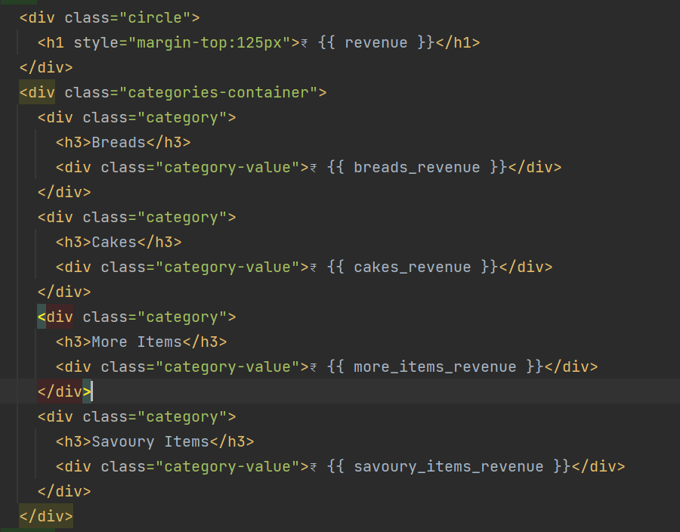

Figure 38: HTML code for monthly revenue page

Jinja to display the total revenue and the revenues for different categories

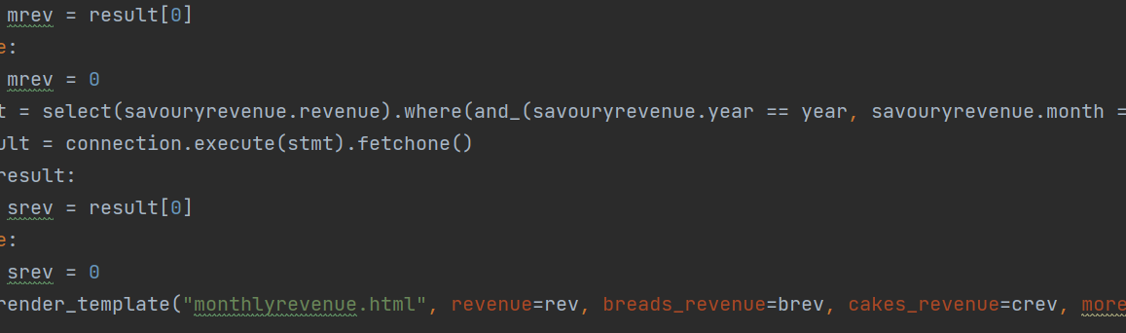

Figure 39: Flask route for monthly revenue

Values passed in the function so the html can render the values using Jinja

Retrieving values from the database

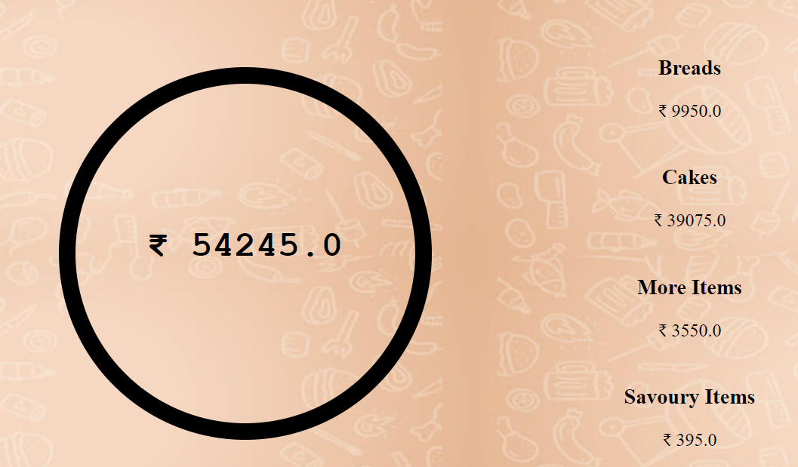

Figure 40: Monthly revenue page with values rendered using Jinja

## Handling file uploads of images

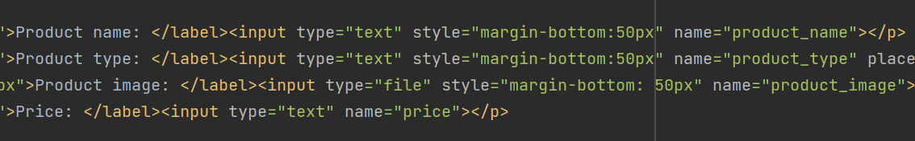

Figure 41: HTML for new item form

Creating input field to input file

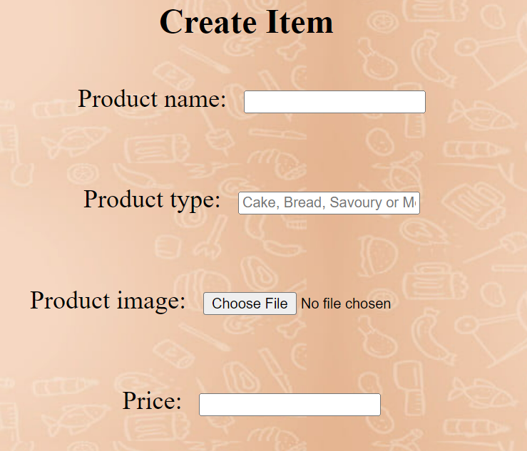

File input field

Figure 42: User interface for new product form

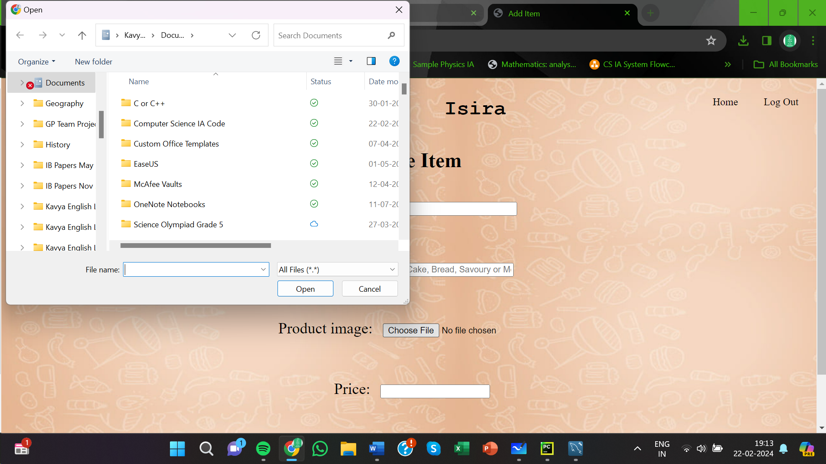

Figure 43: Interface to select and upload image

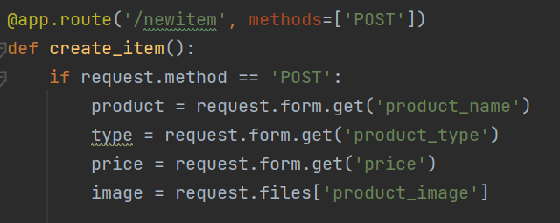

Getting uploaded file from new item form

Figure 44: Flask '/newitem' route

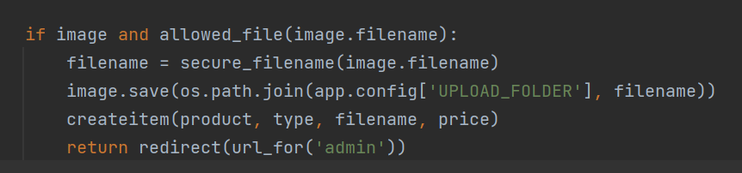

Figure 45: Continuation of '/newitem' route - logic

Use of werkzeug.utils function ‘secure_filename’ to convert filename into secure version

Using .save() function from werkzeug.datastructures library to save the file in ‘uploads’ folder

Checking if an image has been uploaded and if the filename is allowed

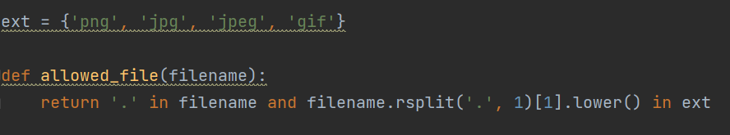

Figure 46: 'allowed_file' function

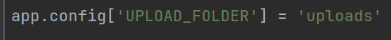

app.config['UPLOAD_FOLDER'] assigned to 'uploads' directory

Figure 47: Defining ‘UPLOAD_FOLDER’

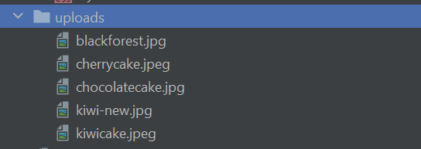

Figure 48: Images stored in 'uploads' folder

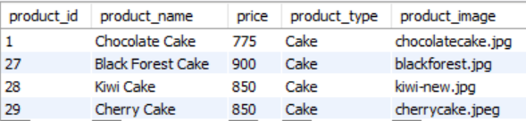

File names stored in database

Figure 49: 'Products' table in database

## Use of alembic to store database transactions and to make changes to the database

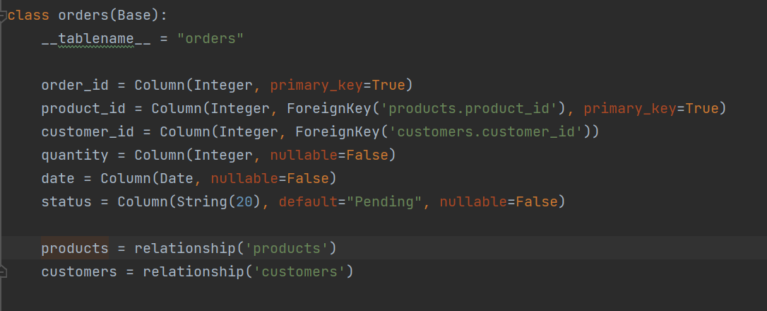

Figure 50: Tables defined

Columns and relationships defined

Table defined as a class

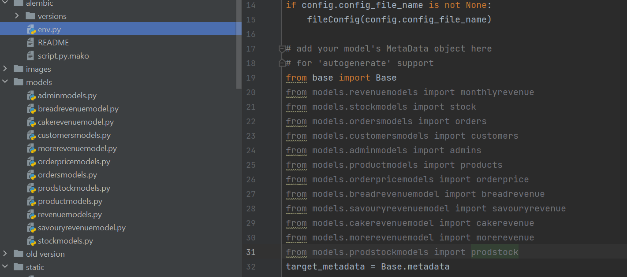

All models/tables added to env.py file in the alembic folder

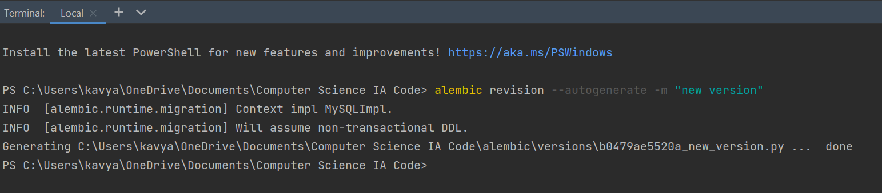

Figure 51: Alembic command in terminal

Alembic command run in terminal – creates revision file with any new or updated tables in env.py

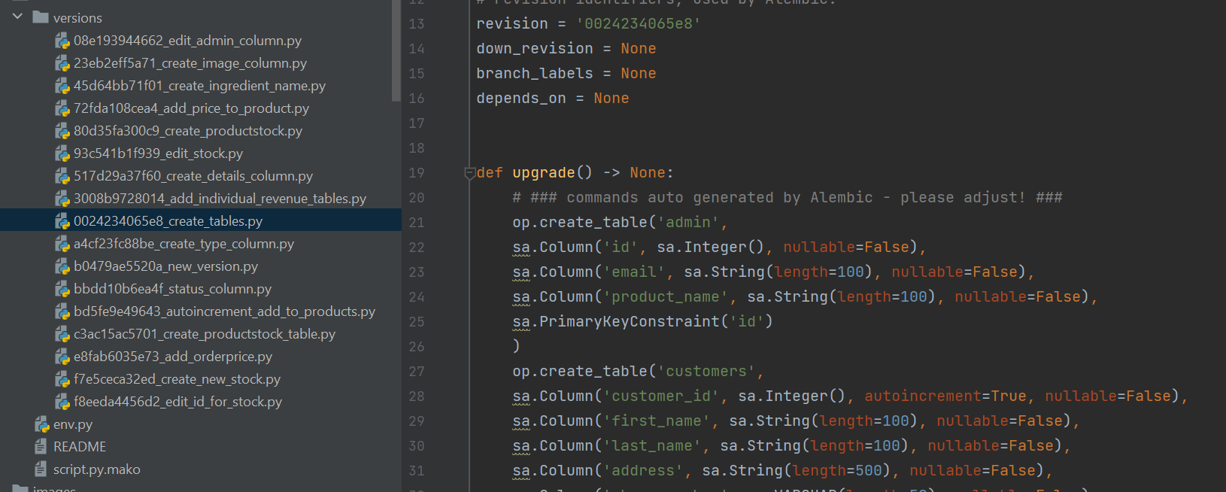

Figure 52: Initial alembic revision file when all the tables were created

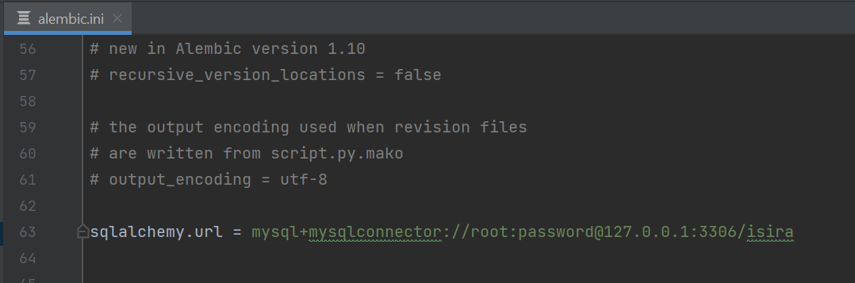

Figure 53: 'alembic.ini' file with mysql connection

MySQL connection to commit changes to database

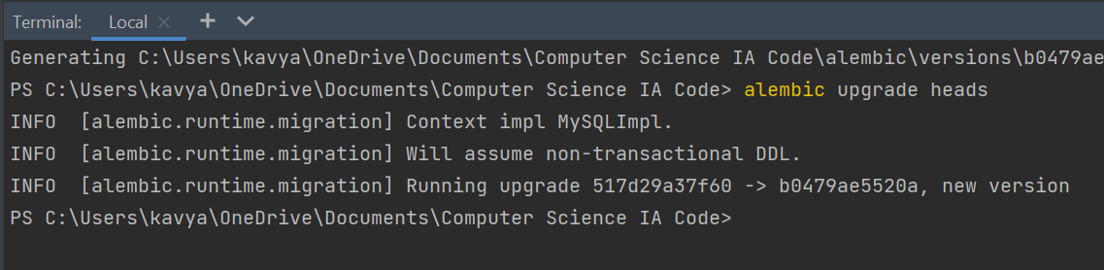

Figure 54: Alembic 'upgrade' command in terminal

‘upgrade’ command commits new revision

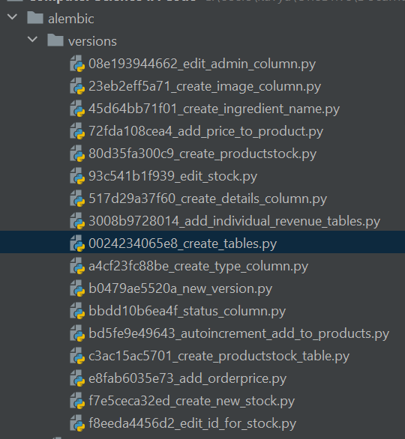

Figure 55: Alembic folder which contains all versions

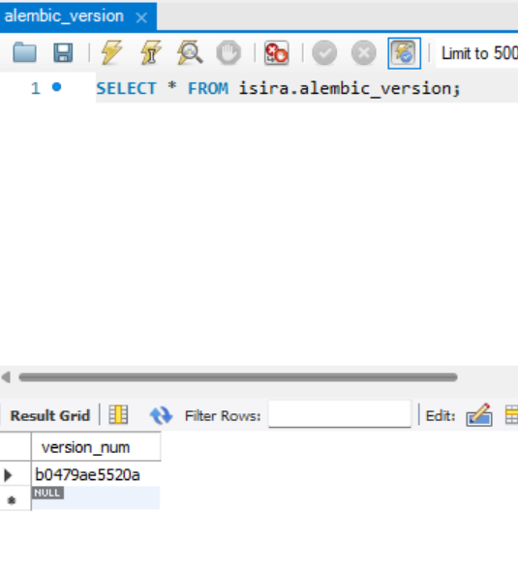

Current alembic version stored in database

Figure 56: 'alembic_version' table in database